* [THE BLOG](https://www.digitaldjtips.com/latest)
* [FEATURES & OPINION](https://www.digitaldjtips.com/category/news/features/)

**The Gear That Shaped Digital DJing In The 2010s**

The past decade has been a turning point for DJ culture: the 2010s cemented digital DJing as the de facto medium for spinning for professional touring DJs, mobile jocks, as well as hobbyists. The ease with which someone can get a song onto his or her laptop or thumb drive, prep playlists, and then spin minutes later was unheard of during the vinyl era, and even during the decade that CDs dominated in the 2000s.

As we step into a new decade, we can only expect digital to permeate DJing further: the rise of music streaming and its slow (but steady) proliferation in the booth will again change the DJ landscape giving everyone almost equal access to all music. And as software and AI improve, the classical role of the DJ as “selector” will continue to evolve in ways that we can’t think of just yet, at an increasingly faster rate.

Here’s our look back at the decade that was. Each year we list our pick for the most influential piece of DJ gear that helped mould the digital DJing landscape we live and breathe in today.

**2010 – Traktor Kontrol S4**

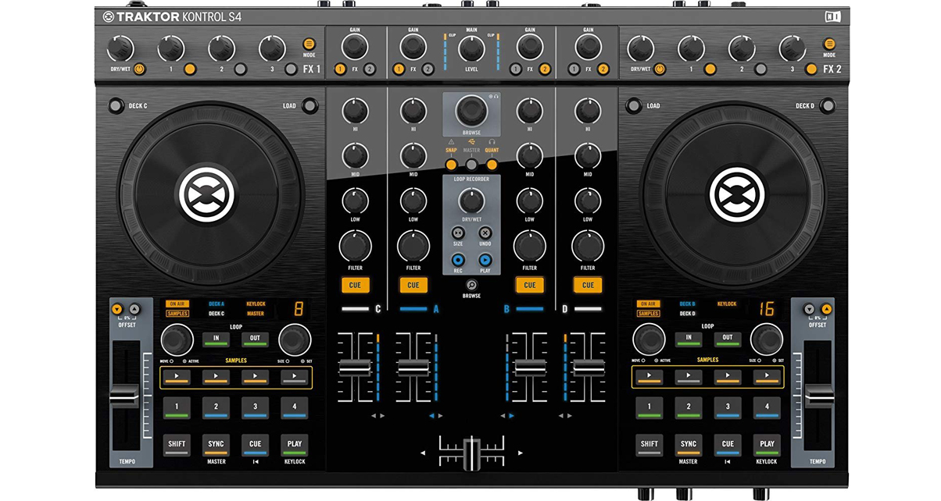  
The decade got off to a solid start with the introduction of Native Instruments’ Traktor Kontrol S4 controller. It was the first big four-channel controller created by NI that was meant to work with Traktor straight out the box. It was groundbreaking because prior to it, almost all DJ controllers were relatively small (at least by today’s standards) and had to be custom mapped to Traktor including the legendary VCI-100 popularised by Ean Golden and DJ Techtools.

The Kontrol S4 ushered in an age where Traktor was at the cutting edge of digital DJing, and is now considered by many digital DJs to be a classic.

**2011 – Pioneer DJ CDJ2000NXS and DJM900NXS**

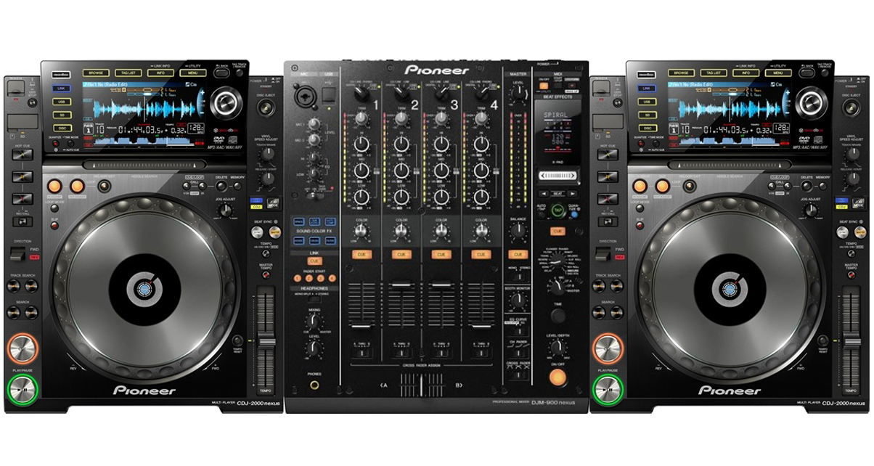  
Pioneer DJ continued to refine its CDJ “vinyl turntable” in the 2000s, but in the 2010s the product had reached its pinnacle: the CDJ2000NXS was reliable, simple to operate, could read music from CD, SD and USB, worked with digital DJ software, and added the sync button.

All of these design and feature additions (including the spec bumps found in the NXS2 range) positioned Pioneer DJ to be the de factor gear brand of the decade, especially during the EDM boom in the first half of the 2010s – you could hardly find a festival without Pioneer DJ branding in the booth. The “turntable” for our digital times.

Read our full review:[Pioneer DJ CDJ2000NXS](https://www.digitaldjtips.com/reviews/pioneer-cdj-2000nexus/" \t "_blank) and [DJM900NXS](https://www.digitaldjtips.com/reviews/pioneer-djm-900nexus/)

**2012 – Pioneer DJ DDJ-SX**

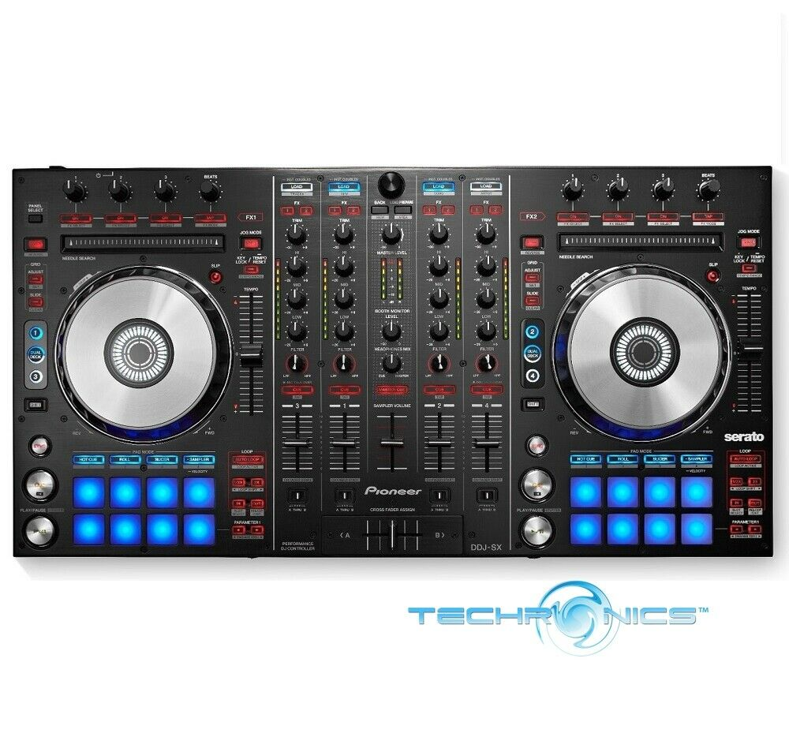

Pioneer DJ released the full-featured, slick DDJ-SX early in the decade and it presented a paradigm shift for DJ controllers: it was big and looked like it actually belonged in the DJ booth thanks to its layout that was similar to how a CDJ/DJM set-up looked.

By eschewing a small footprint and quirky stylings (other controllers looked a bit like toys at the time) in favour of power and a “grown up” feature set, the DDJ-SX set the stage for bigger, more serious, more expensive digital DJ controllers that would come to dominate the latter half of the 2010s.

Read our full review: [Pioneer DJ DDJ-SX](https://www.digitaldjtips.com/2012/11/pioneer-ddj-sx-serato-dj-controller-review/)

**2013 – Traktor DJ for iPhone**

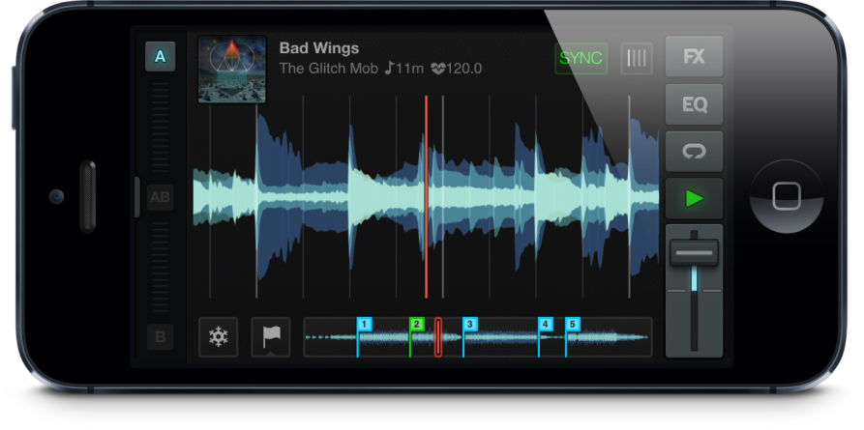

With the release of the iPhone in 2007, it was only a matter of time before digital DJ software would land in the smartphone space. Fresh off the runaway success of the original Traktor Kontrol S4 and Kontrol S2, Native Instruments set its sights on dominating handheld DJing with the introduction of Traktor DJ for the iPhone.

While there were other iOS DJing apps already, none had the pedigree that Trakor DJ had, and it showed: it was like a streamlined Traktor experience right on your phone complete with the UI and layout, plus performance features like Freeze and Flux.

If you were a Traktor user, you could prepare music on your phone, sync metadata to the cloud and have your Traktor software update its library on your computer. Sadly, cloud integration came and went through the years, leading to frustrations. Still, it was a pivotal moment for smartphone / tablet DJing, even if that medium for digital DJing has yet to take off.

Read our full review: [Traktor DJ for iPhone](https://www.digitaldjtips.com/reviews/traktor-dj-iphone/" \t "_blank)

**2014 – Numark NV**

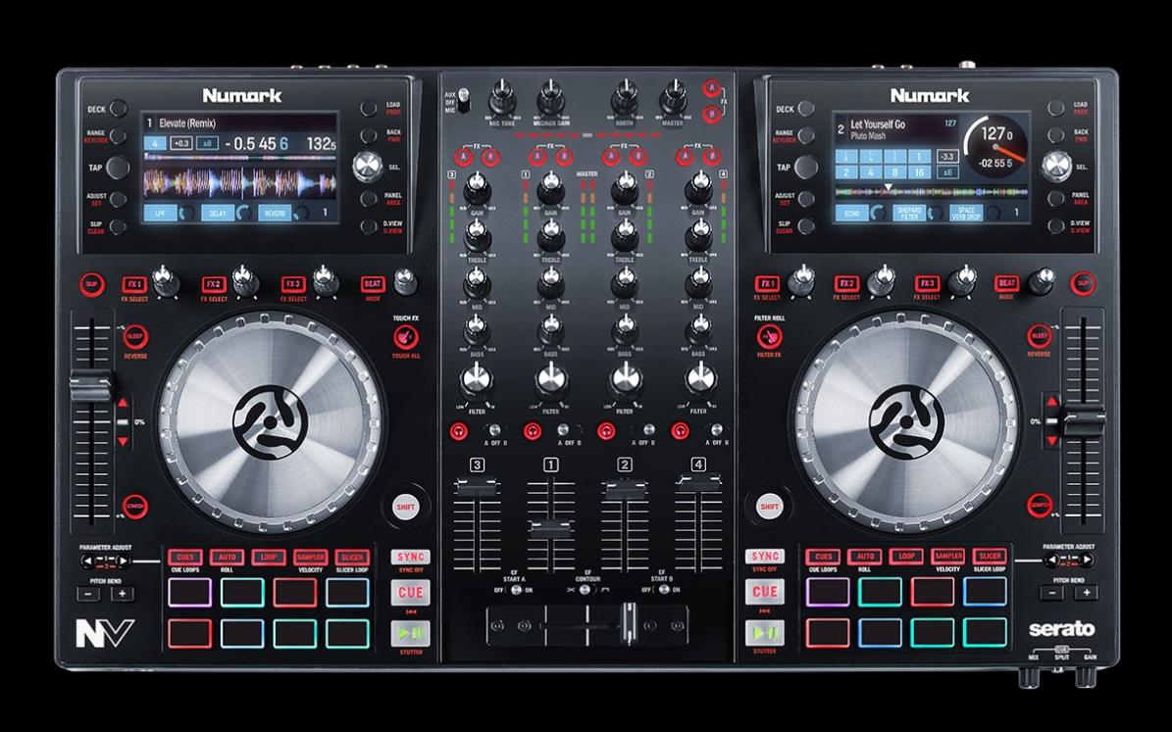

By the middle of the decade, DJs felt like they were staring at their laptop screens too much (unfairly dubbed “Serato face”, since it applies to any DJ software anyway). Numark decided to do something about it and released the first mass market DJ controller that had built-in screens. The idea was that you’d look less at your laptop and more at your crowd since you had displays on the device that showed you waveforms and track data.

While the screen was rudimentary (don’t expect a smartphone experience) DJs who bought it found it quite useful, and you could find traces of this design decision in today’s controllers (with much improved screens of course) like the Pioneer DJ DDJ-1000, DDJ-800, and Reloop Touch.

Read our full review: [Numark NV](https://www.digitaldjtips.com/2014/09/review-video-numark-nv-serato-dj-controller/" \t "_blank)

**2015 – Pioneer DJ DDJ-SB2**

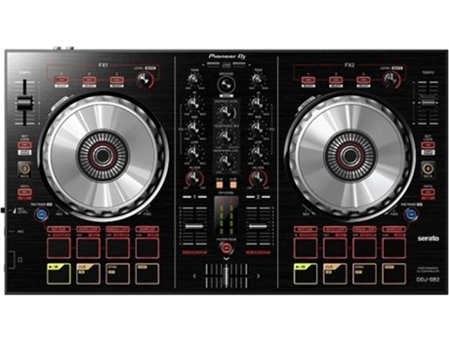

As EDM swept the world, more and more folk got interested in the art of DJing and wanted to try it out. The early 2010s probably saw the most number of beginner-focused DJ controllers ever with different manufacturers throwing their hat in the ring to get a slice of the action, and while there were a lot of solid beginner controllers good enough for gigging (Numark Mixtrack Pro, [Reloop Beatmix](https://www.youtube.com/watch?v=IYdzXwdI7TY), Traktor S2) it was the DDJ-SB2 that packed the most power and software compatibilities (ships with Serato, but also works with Traktor, Virtual DJ and Rekordbox DJ).

The DDJ-SB2’s features and layout set the tone for more entry-level controllers from Pioneer DJ (eg DDJ-400, DDJ-200) and may have even served as some small inspiration for other beginner-focused companies (the [Hercules Inpulse 300](https://www.digitaldjtips.com/reviews/hercules-djcontrol-inpulse-300/) comes to mind).

Read our full review: [Pioneer DJ DDJ-SB2](https://www.digitaldjtips.com/reviews/pioneer-ddj-sb2/)

**2016 – Pioneer DJ DJM-S9**

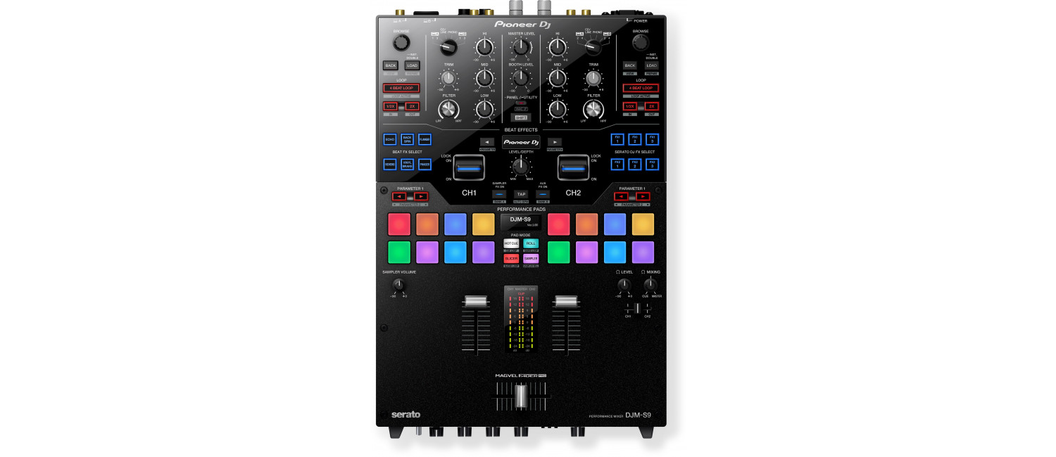

Battle DJing came back with a vengeance in the 2010s thanks to worldwide mega battles like the Red Bull 3Style and DMC championships. Livestreaming and YouTube also played an integral role in spreading scratch DJ culture and turntablism, making it easier to access scratch tutorials and routines to break down and learn from (remember when you had to buy VHS tapes of battles just to study them?).

And while battle DJing is almost synonymous with vinyl culture, a new breed of scratch DJs harnessed the power of digital DJing to take their creative routines further. To address the needs of new battle DJs, Pioneer DJ came out with the DJM-S9 which featured effect paddles, hot cue pads and adjustable crossfader settings so you can fine tune your scratching experience to taste. Pricey, but could be found in tons of performance and battle routines online and off.

Read our full review: [Pioneer DJ DJM-S9](https://www.digitaldjtips.com/reviews/pioneer-djm-s9/)

**2017 – Denon DJ SC5000 / X1800 Prime**

**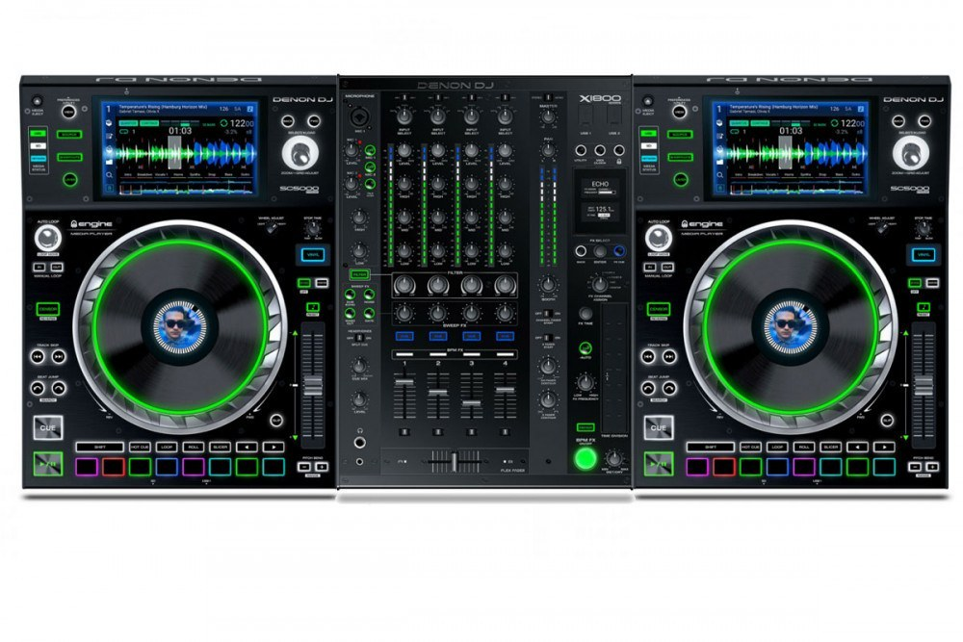**

Pioneer DJ continued to flex its dominance in club booths and the festival circuit throughout the 2010s and it remained relatively unchallenged until 2017. This was when Denon DJ unveiled its Prime Series kit. The “CDJ killer” consisted of the SC5000 Prime media player and the X1800 mixer, both of which boasted more advanced technology than Pioneer DJ’s current NXS2 club standard.

The SC5000 Prime in particular is an impressive piece of hardware that had dual layer functions (ie you could play two songs on one unit) a huge touchscreen with gesture control for an experience closer to that of a smartphone, and onboard processing that allowed the unit to analyse tracks. It can even now access the internet and connect to TIDAL for streaming music straight from the device. Truly the next generation of professional DJ gear, and one that Pioneer DJ has yet to challenge.

Read our full review: [Denon DJ SC5000](https://www.digitaldjtips.com/reviews/denon-dj-sc5000-prime/" \t "_blank) / [X1800 Prime](https://www.digitaldjtips.com/reviews/denon-dj-x1800-prime/)

**2018 – Rane Seventy-Two and Rane Twelve**

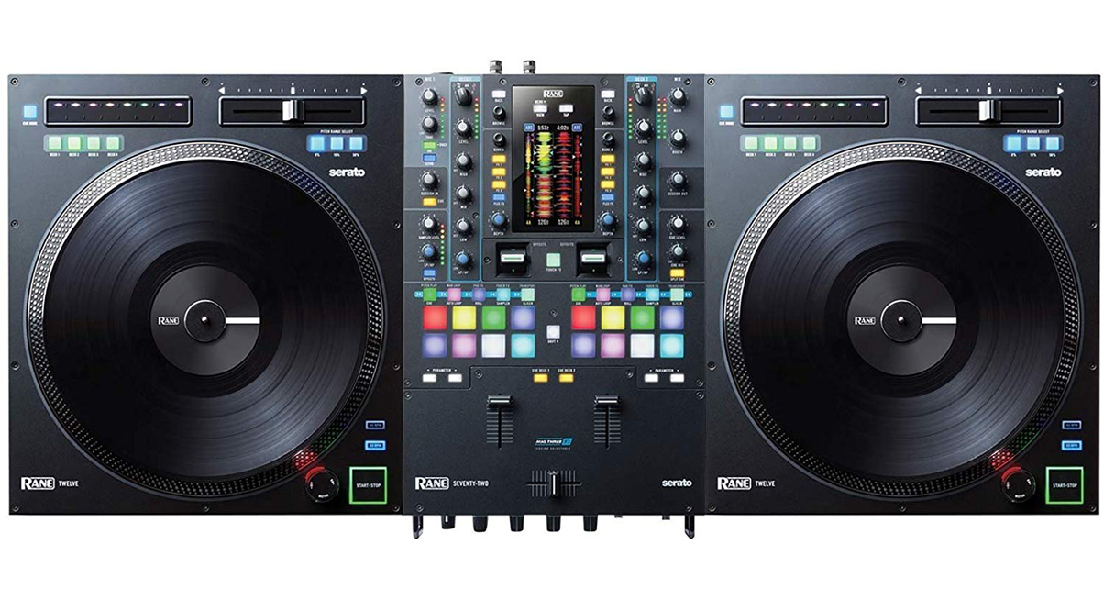

While esteemed DJ company Rane put out some impressive kit in the past decade (the MP2015 rotary mixer is still at the top of my wishlist if I win the lottery) the company’s new flagship battle system showed the DJ world what was possible when the lines between turntablism and digital are truly blurred. The Rane Twelve is a motorised controller with a spinning platter that has torque similar to a Technics 1200, giving it an authentic turntable feel while you spin with MP3s on Serato DJ.

Paired with the Seventy-Two mixer, you get all of the benefits of spinning with a DVS turntable set-up (turntable’s analogue feel, tactile response, size and power) without the hassle of having to use cartridges, and even eliminating skipping needles at festivals, booths and mainstage gigs. Coincidentally, also at the top of my wishlist (Rane makes seriously sexy kit, no doubt).

Read our full review: [Rane Seventy-Two](https://www.digitaldjtips.com/reviews/rane-seventy-two/" \t "_blank) and [Rane Twelve](https://www.digitaldjtips.com/reviews/rane-twelve/" \t "_blank)

**2019 – Denon DJ Prime 4**

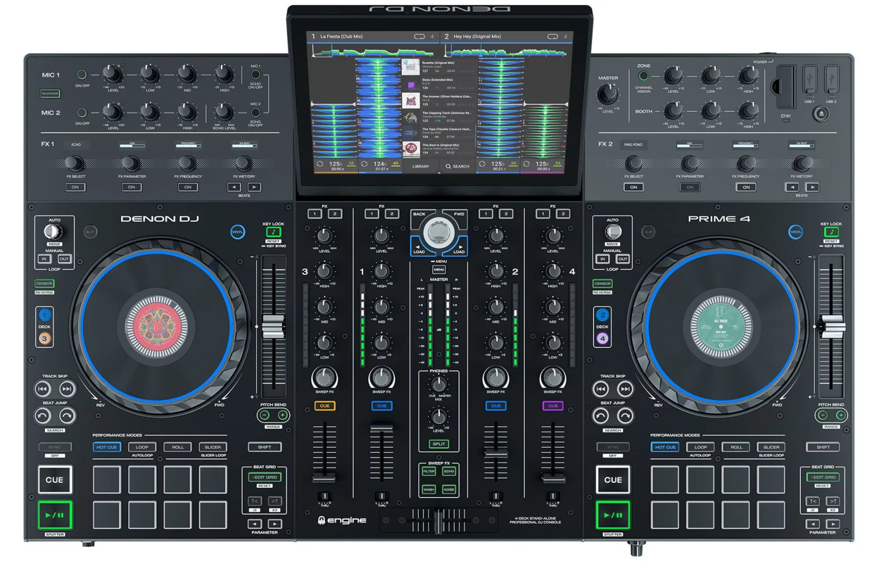

Our final entry in this list is what we consider to be the torchbearer for the future of digital DJing: Denon DJ unveiled the Prime 4 at the 2019 NAMM Show, and it is the single most powerful four-channel all-in-one standalone device you can get today. It’s a powerhouse for gigging DJs, mobile DJs, and even touring DJs because of all of its connectivity options as well as its onboard processing.

The large touchscreen makes library management easy (bye bye laptop!) and its built-in WiFi lets you go online to access streaming services like TIDAL. While it isn’t perfect, Denon DJ has been quick to issue firmware updates, and it will only get better with time. Pioneer DJ was first to market an all-in-one standalone with the XDJ-RX back in 2015, but it didn’t feel like the future even back then. The Prime 4 feels like tomorrow’s technology, which may just be part of a digital DJing landscape where laptops are no longer required.

Read our full review: [Denon DJ Prime 4](https://www.digitaldjtips.com/reviews/denon-dj-prime-4-standalone-all-in-one-system/" \t "_blank)

**Special Mention – Phase DJ**

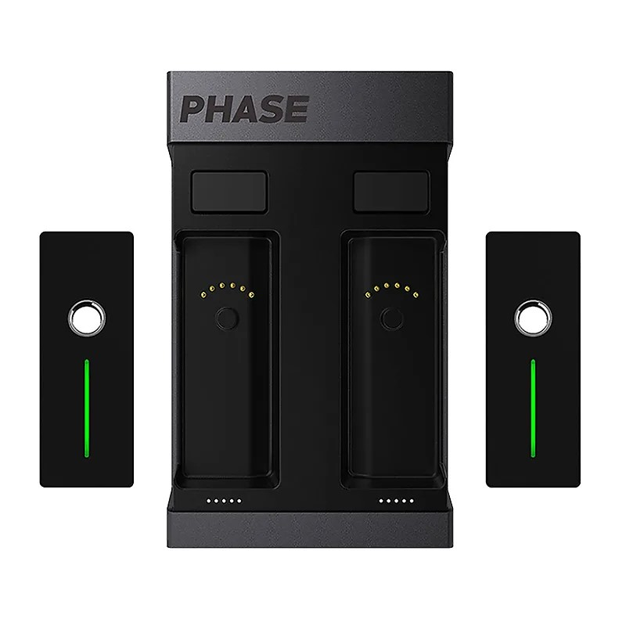

Digital vinyl systems were the first kind of digital DJing developed in the early 2000s (it was called Final Scratch and was co-developed by Stanton and Richie Hawtin before being bought by Native Instruments). There were few innovations in the DVS space though, that is until Phase DJ came along.

It’s basically a wireless timecode kit that lets you do away with the special timecode vinyl needed for DVS, and you didn’t need cartridges and stylii too. The prototype was debuted at NAMM 2018, and it stole the show and got nods from battle DJs, turntablists, and even legends like Jazzy Jeff.

Production delays, battery issues and connection troubles have plagued Phase DJ since its official launch earlier this year, but the company has been making good on its promises to improve the product, so it’s currently a work in progress.

Read our full review: [Phase DJ](https://www.digitaldjtips.com/reviews/phase-wireless-timecode-system-for-dvs/)

**Finally…**

The past decade was huge for digital DJing because we saw the medium mature and become the preferred method for spinning. That said, vinyl DJing – though niche – isn’t likely to go away anytime soon either: there’s been renewed interest in the format and art, thanks to events like Record Store Day and vinyl-only DJ sets.

What this all means is that DJs today have more choice than ever before, and the blurring of boundaries between analogue and digital (eg DVS, Rane Twelve set-ups) means that we have even more opportunities for creative performance and preparation. We can’t wait to see what the next decade of DJing will bring!